Database Development and Class Registration

Dallas Spencer

The University of Arizona Global Campus

CST 499: Capstone for Computer Software Technology

Instructor: Charmelia Butler

January 22nd , 2025

The goal of the second implementation phase, week 4 assignment, is to implement the course scheduler with the ability to add and remove courses to the student. The hardest part of this task is getting the form to function properly. When reviewing the screenshots of the project, some of the HTML functions I've created to push the data across to the function are visible, but in the final project will be cleaned up with Bootstrap.

The pages developed do function and successfully add the information to the student and views it under their profile. Within the profile, the student can unenroll in their selected courses. Overall, the software functions and the databases are correctly managed within the software. Through the implementation phase the most difficult part is learning how quickly fixing one problem can create another problem within the code.

The added functions leverage the “Foreach” operation with containers and HTML form tags to successfully add the courses to the student and communicate to the databases. Instead of PDO, the project uses mysqli functions to query on the database and display the proper information for the student.

In conclusion, the completed software allows for students to sign up for classes by semester. It allows for students to remove the schedules they assigned themselves as well. The implementation phase was a learning curve on the second phase, whereas the first phase of the login page, landing page, and registration page was fairly simple.

**Source code and webpages:**

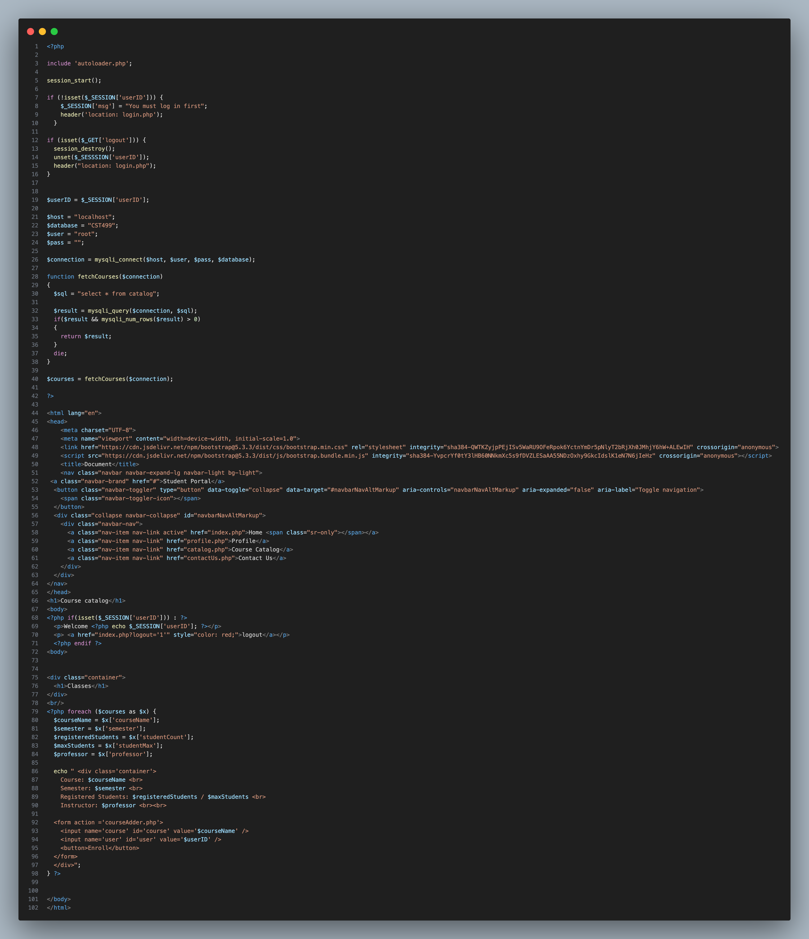  
Figure1: catalog.php

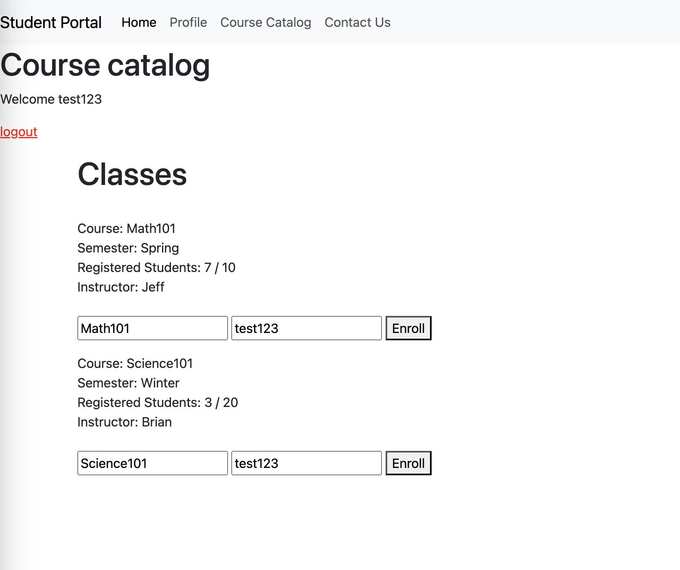Figure 2: Catalog website

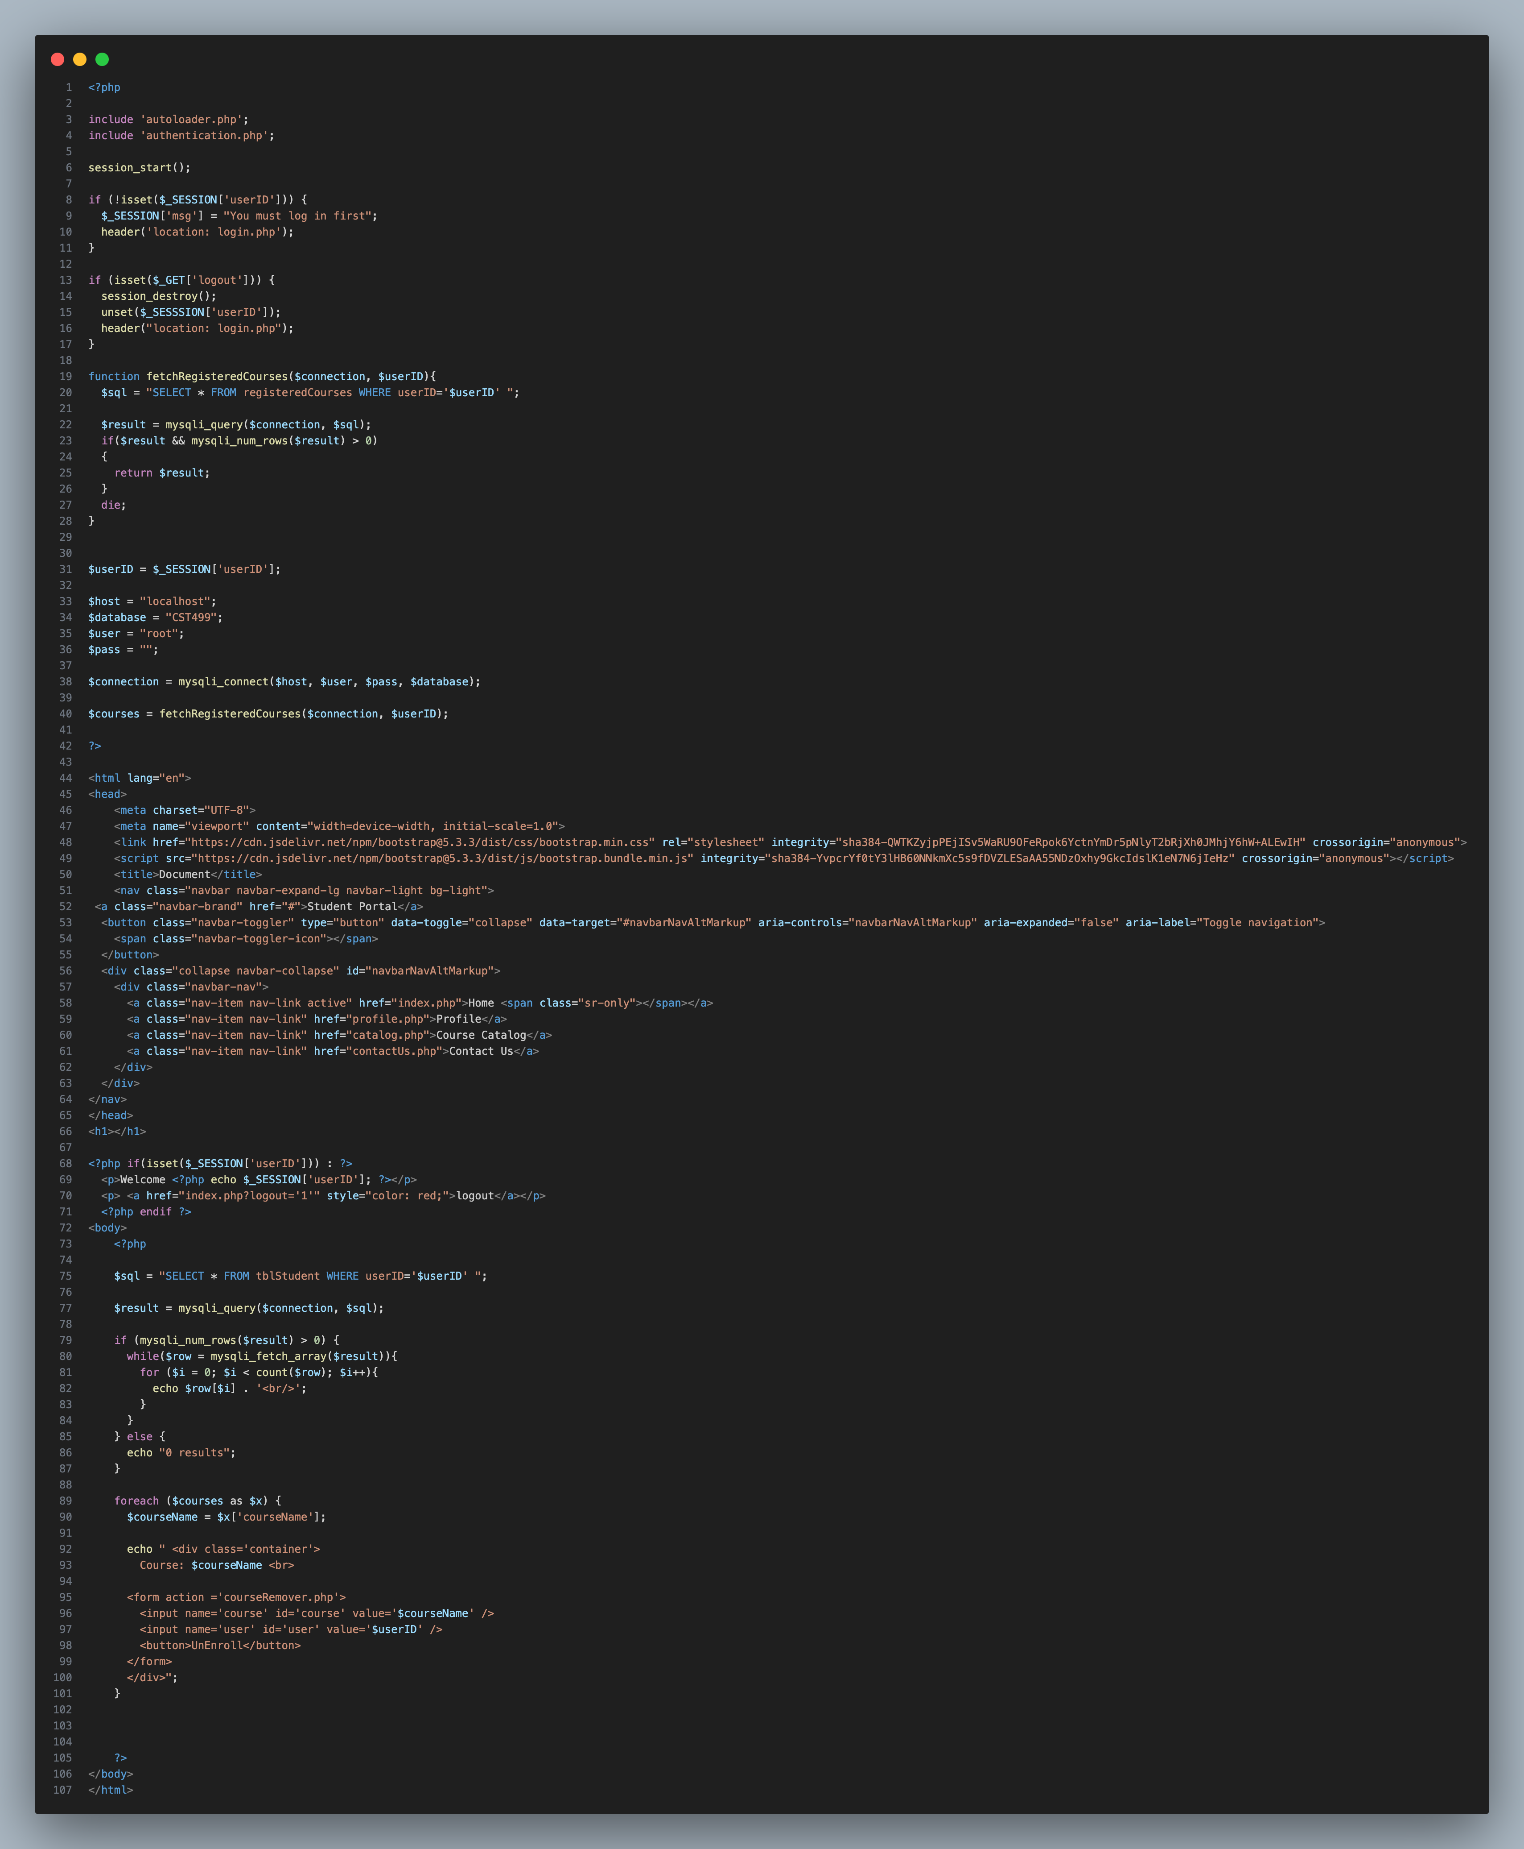Figure 3: Profile.php (updated to view subscribed to courses)

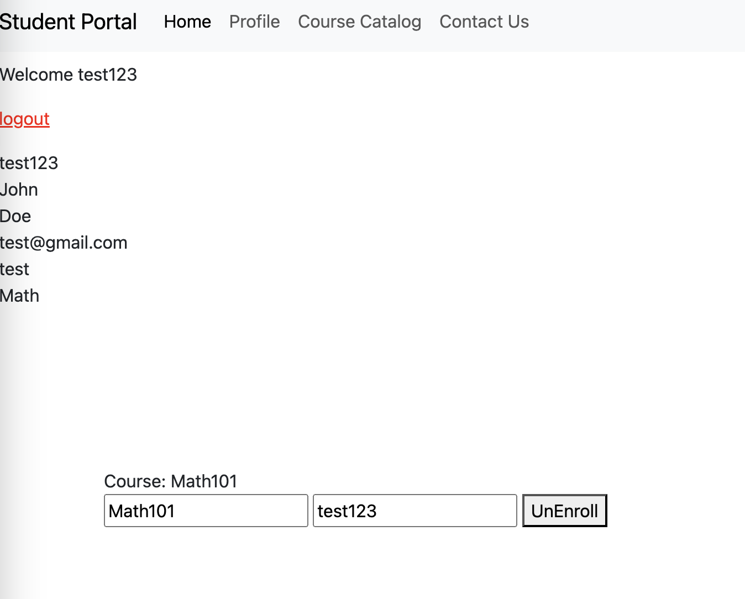Figure 4: Profile webpage

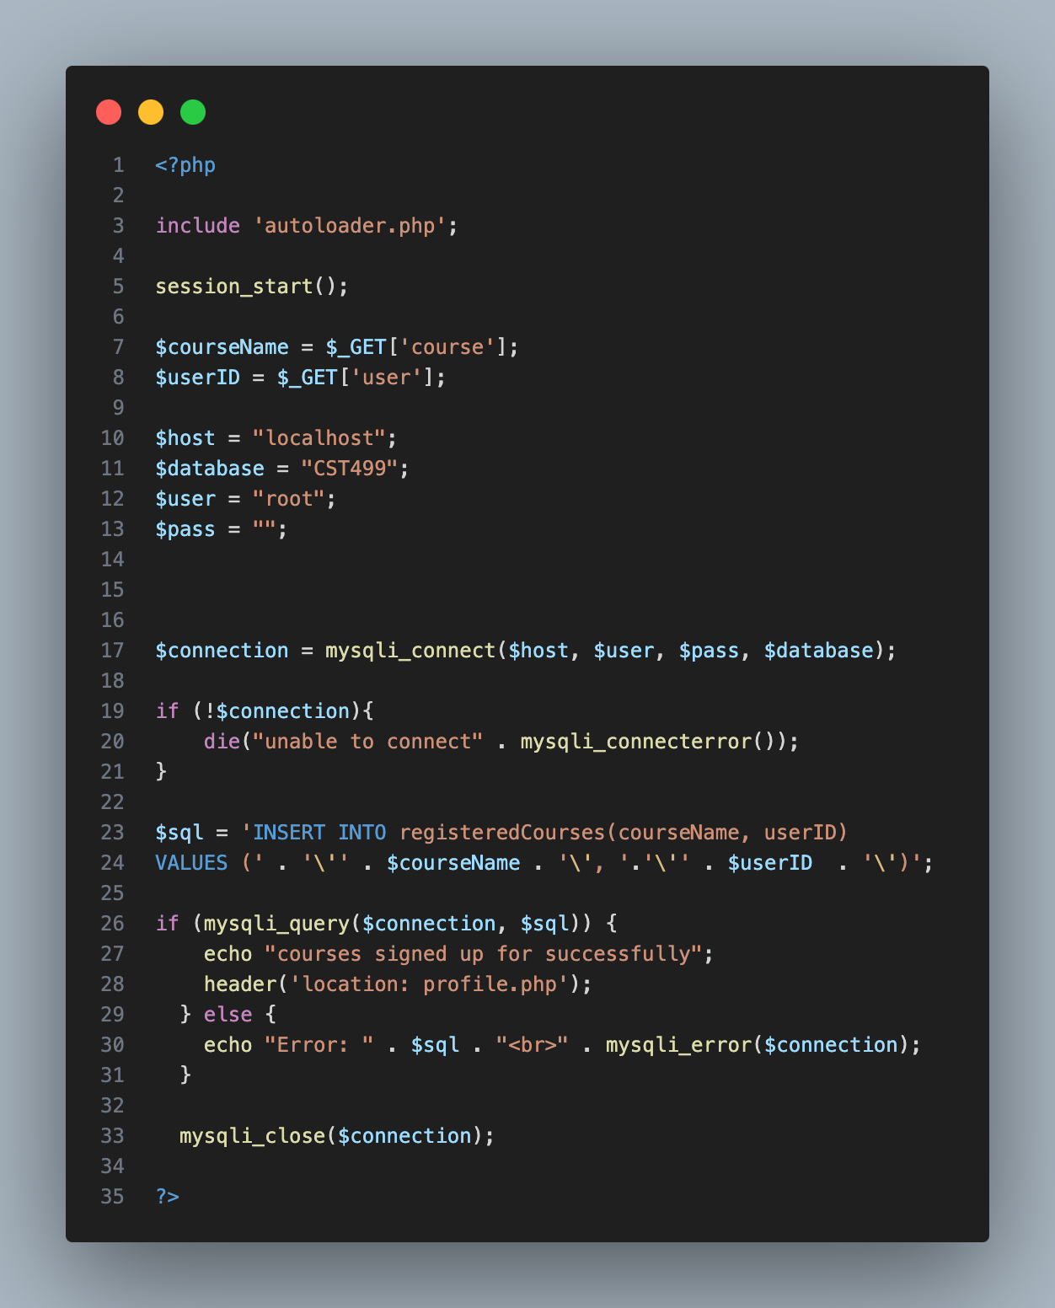

Figure 5: courseAdder.php

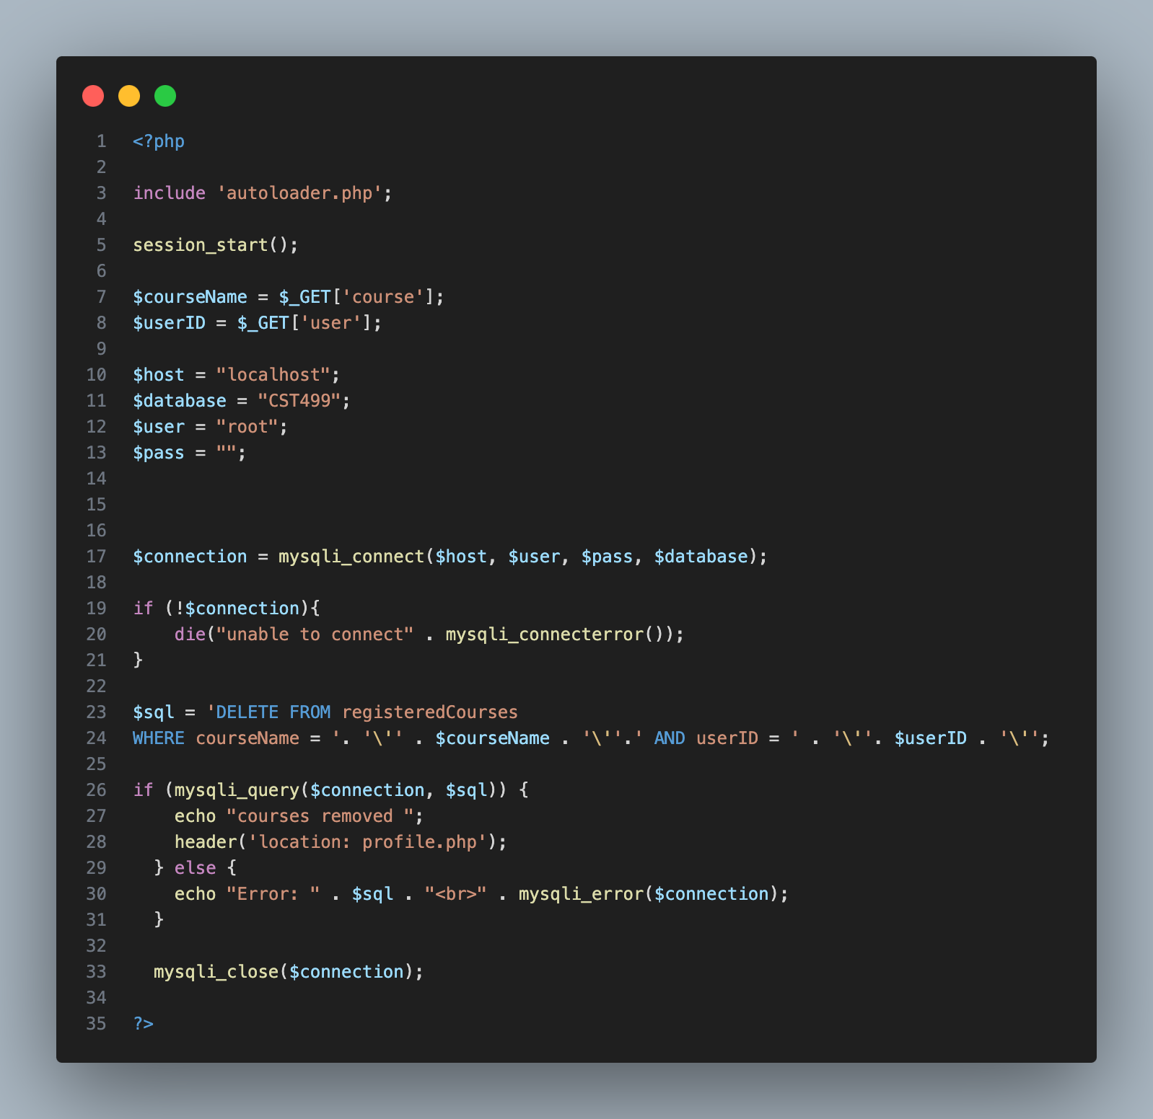Figure 6: courseRemover.php

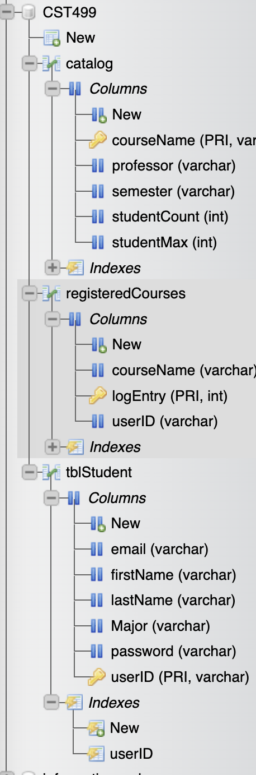  
Figure 7: Database with tables and columns

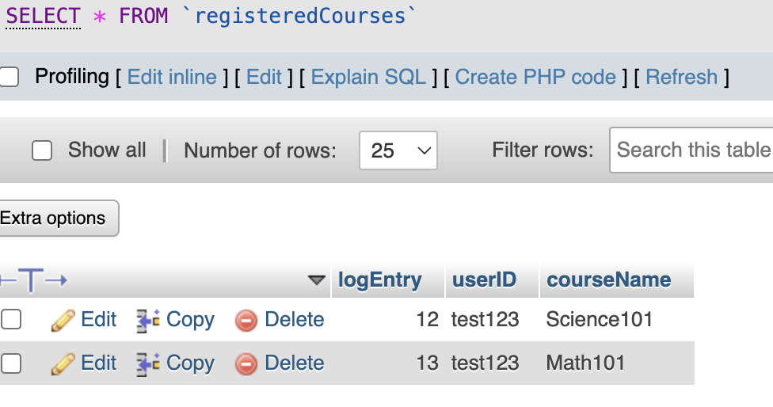

Figure 8: Table with added classes for the student

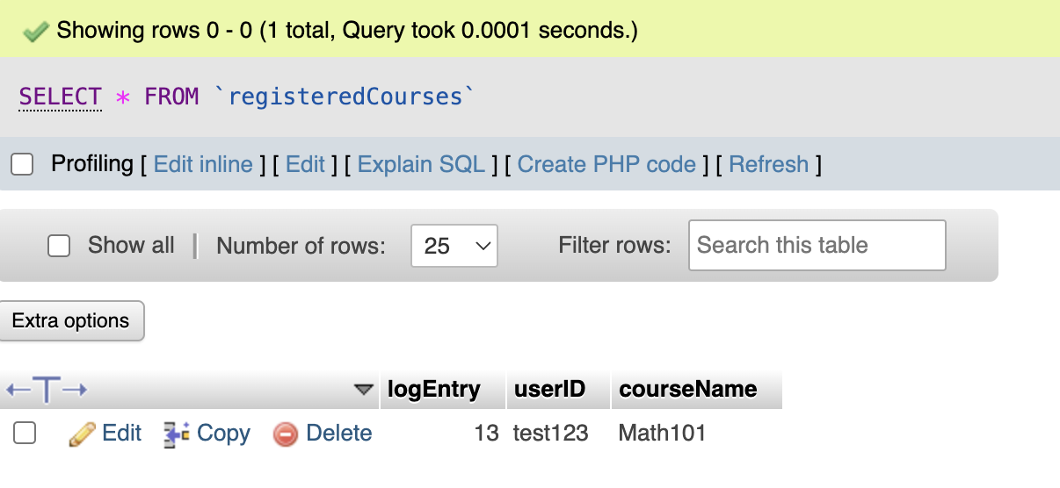

Figure 9: Table after removing from the DB for logEntry 12 through the webpage profile.php

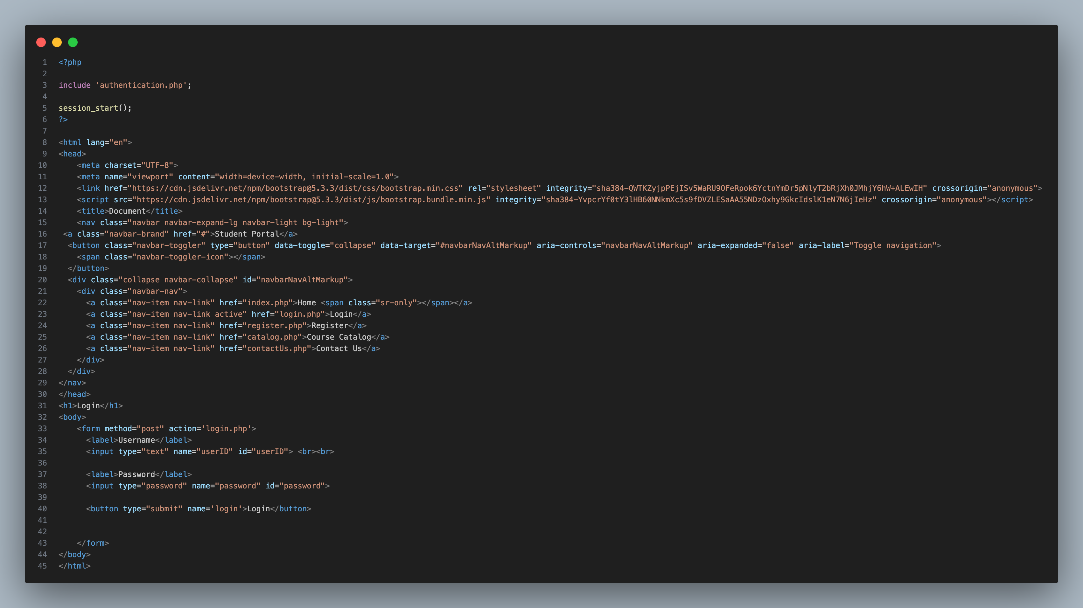Figure 10: login.php

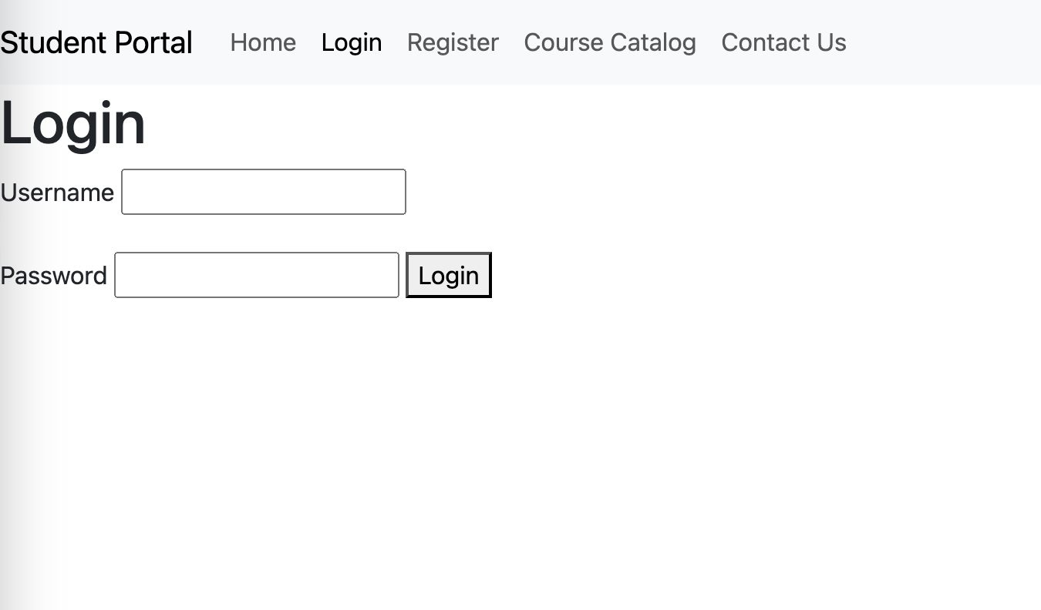Figure 11: Login webpage

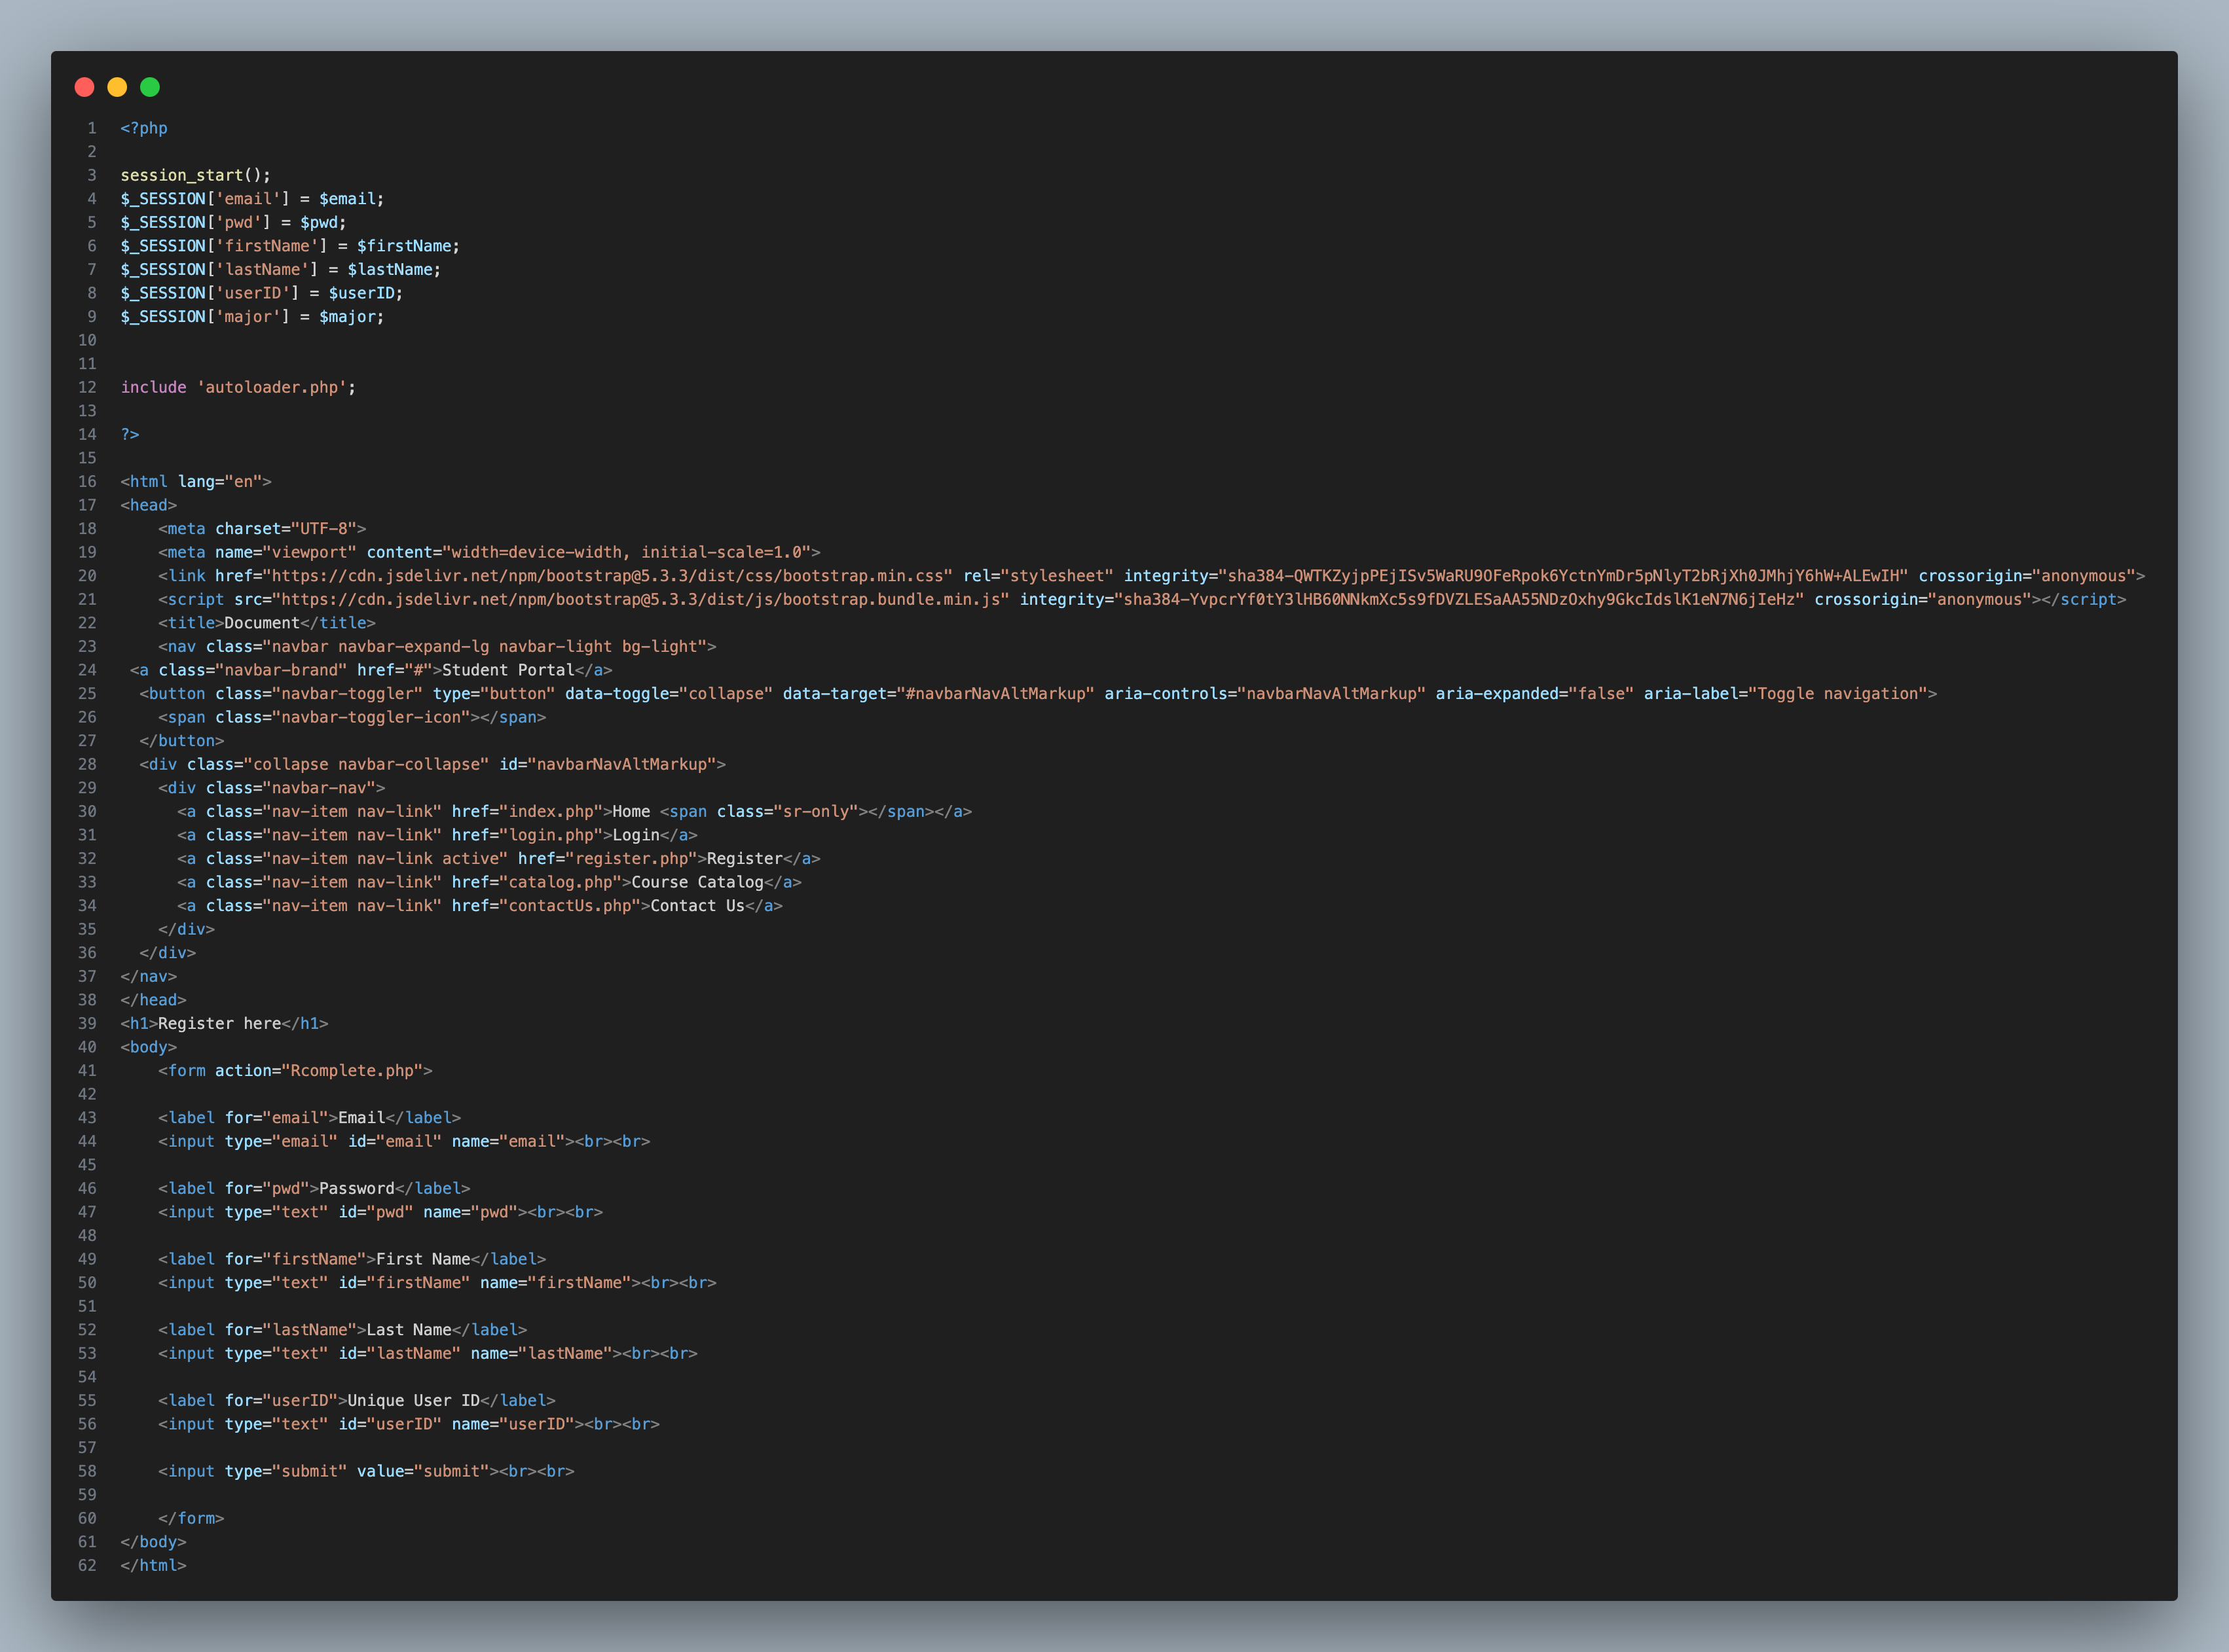Figure 12: Register.php

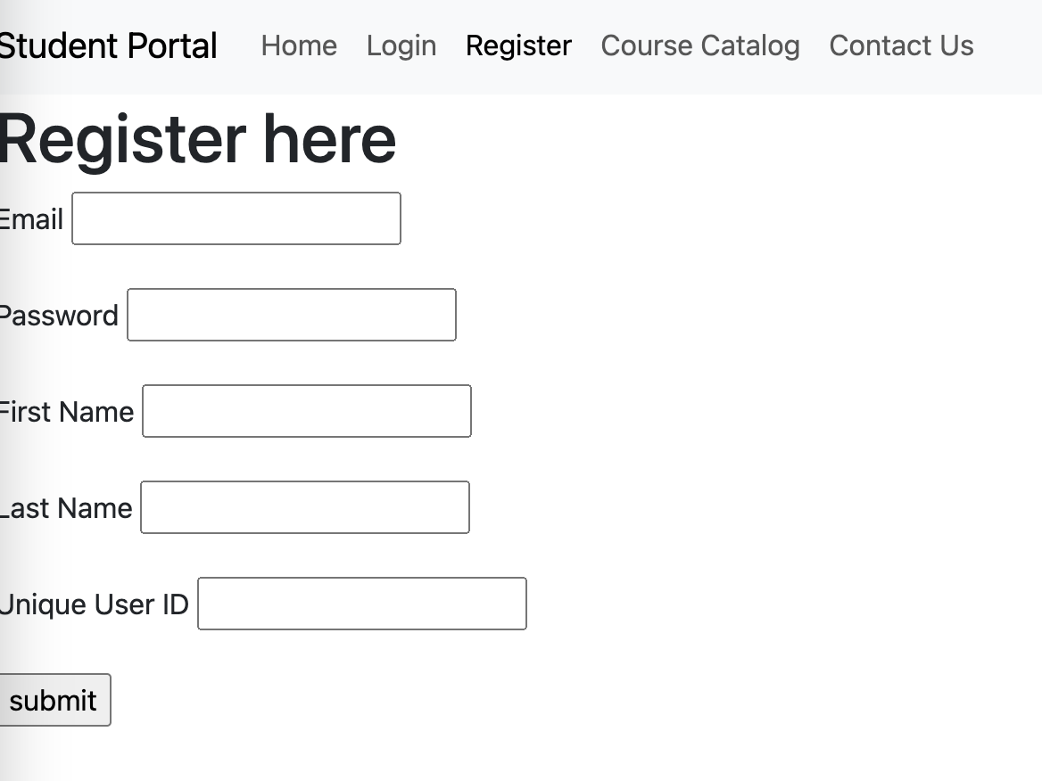Figure 13: Registration page

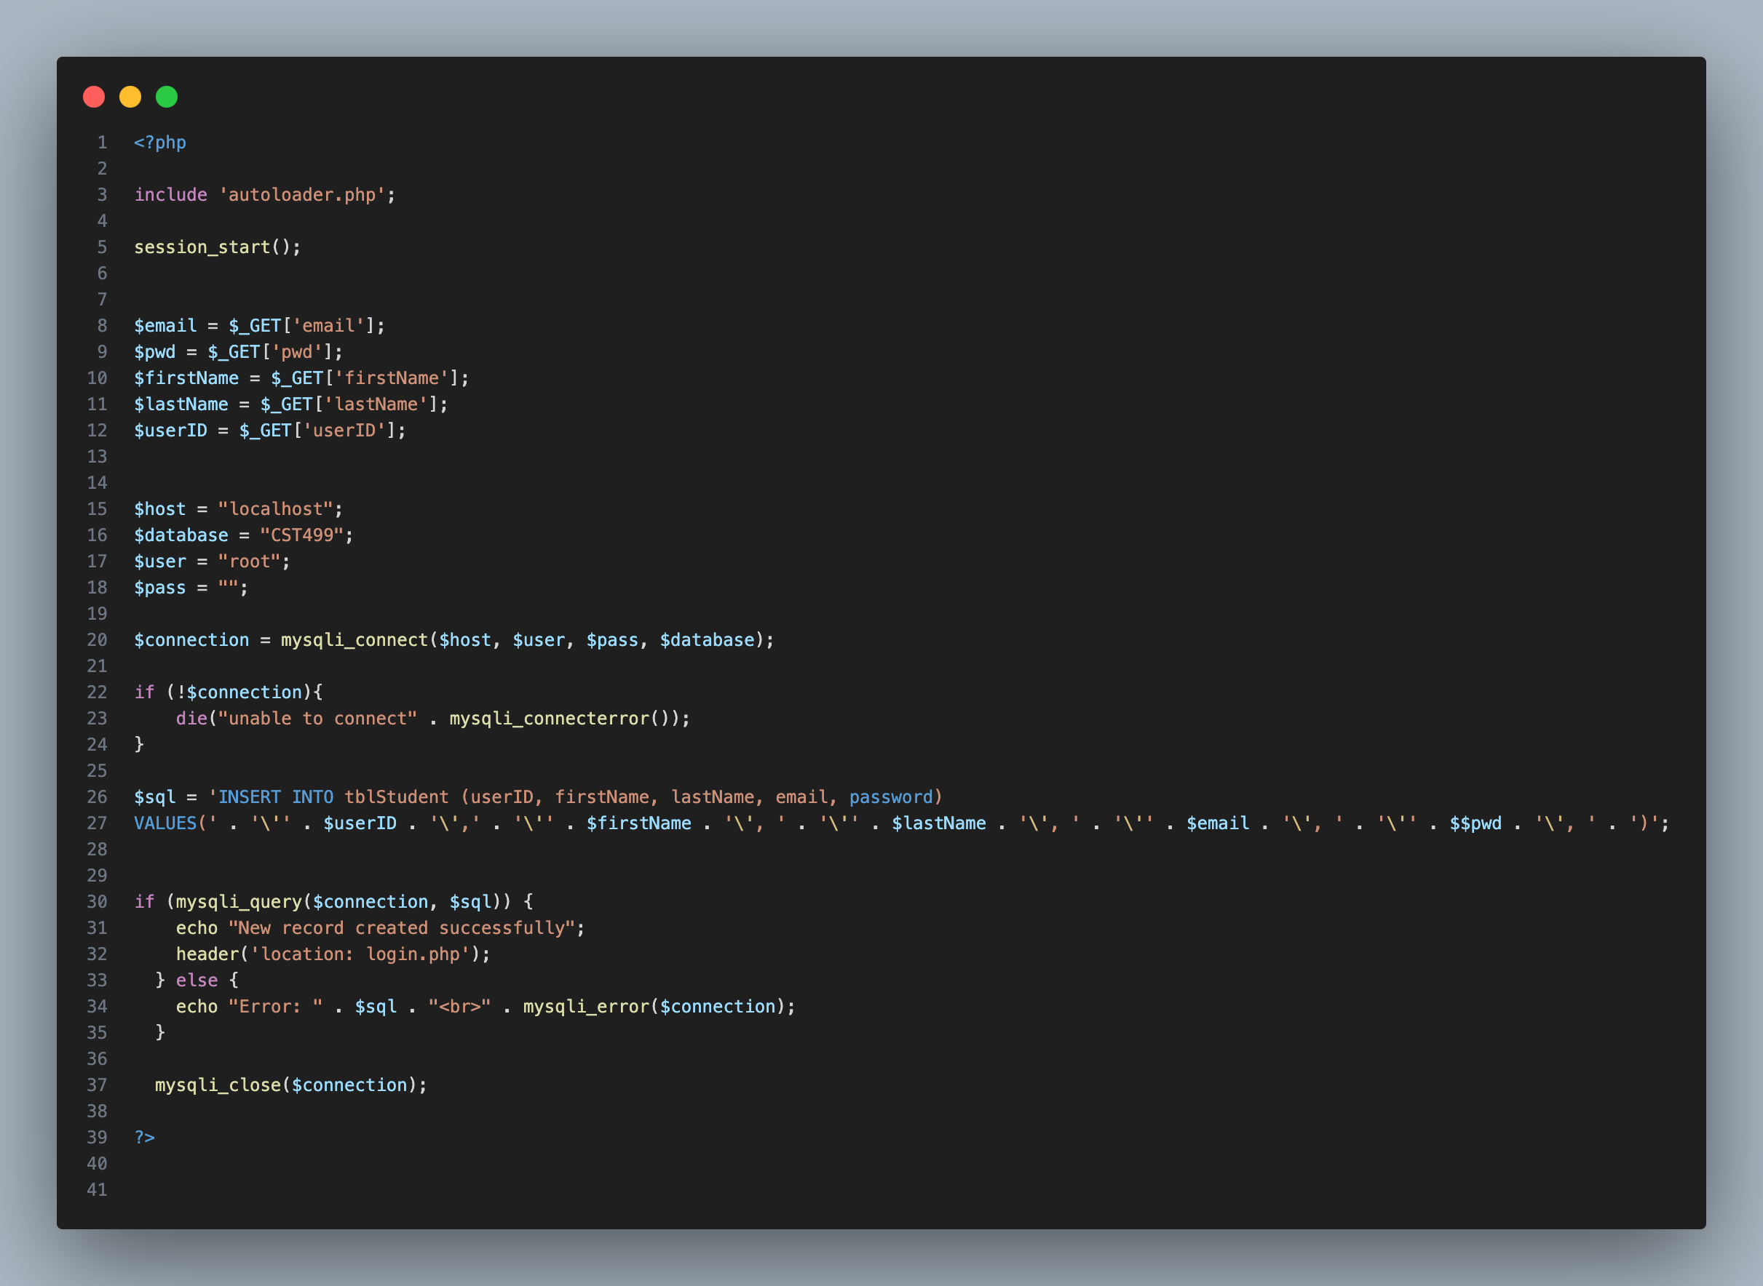Figure 14: Rcomplete.php